Risk Factors.

The risk factors that affect our portfolio and their different asset classes are the following:

* Stocks[1]
* Underlying Option’s Stocks[2]
* Foreign Exchange[3]
* USD Zero Rates ( US Treasury Active Curve and the correspondent term structure with 15 points[4])
* CAD Zero Rates (Canada Sovereign Curve and the correspondent term structure with 15 points[5])
* EUR Zero Rates (German Sovereign Curve and the correspondent term structure with 15 points[6])
* Hazard Rates for the CDS (eight-point term structure)[7]

The following bonds are considered as benchmark for the zero rates needed for the calculations. The points are considered using a bootstrapping method.



For the hazard rates, we obtain the spreads of the following CDS, and transform them to hazard rates with the following equation:

$$λ(t)=\frac{s(t)}{1-R}$$

The following CDS spreads were used to obtain the lambdas:



















Notice that for our initial position in Huntsman Int. there is no public information about the spreads. So we found a similar company with similar ratings to obtain the spreads to use; that was Dow Chemicals.

The explanation of the risk factors is the following:

* The stocks are needed to simulate the future prices and losses that can occur in the fall of the prices of our positions.
* The underlying in the options is the main factor that changes the prices of the options.
* The FX can derive in changes in our portfolio, according to the original currency in which our assets are issued and how they are measured against the CAD; in the portfolio we have assets in USD, CAD and EUR. So the currencies that are not in CAD we are exposed to risks
* The zero curve rates, as most of our positions are exposed to interest rates changes that may change the price of the portfolio. As mentioned previously, each currency has its own issuing rate structure that can affect the price of options, CDS and corporate bonds
* Hazard Rates, are included for each different CDS. Calculated from the spreads, are the most important risk factors of our CDS’s.

Data gathering and information.

For the available historic data, we extracted the information from Bloomberg. For the missing data in the calculations of the different VaR methods (period 2014-2016), we unified the dates. And if some data was missing (not in a lot of cases), we decided to eliminate that date.

For all of our assets, we could find the correct information in Bloomberg in that period of time. Just for the following we proceeded differently:

* CDS: as mentioned previously, the CDS from Huntsman Int. there is no public information about the spreads. So we found a similar company with similar ratings to obtain the spreads to use; that was Dow Chemicals.

For the Stressed period in 2007-2009, we were able to find all the information required for our risk factors, except for the lambdas. In that case we decided to do a linear regression of the following indexes of CDS:

* ABD HY
* ABC IG

So, we did a linear regression to obtain the spreads of the CDS, and transform them into the hazard rates (with an assumption of 40% recovery rate given in Bloomberg).

Stress Testing Scenarios

To create different scenarios can help us determine the amount of risk we may be exposed; driven by different changes in the risk factors. We need to consider also that for this part of the report, we can assume different historical scenarios to see what happens with our risk measures. The scenarios we considered are the following:



* LTCM default and Russian Crisis Default (1998)
* Credit Crisis and Lehman Brothers (2008)
* Greece (2010)
* Debt Ceiling Crisis and Downgrade US (2011)
* Own Scenario

The following graphs show the losses driven by the following stressed scenarios considered:

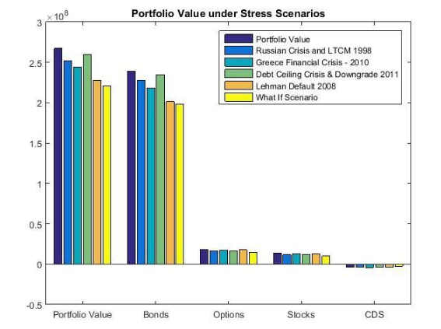

First Scenario:

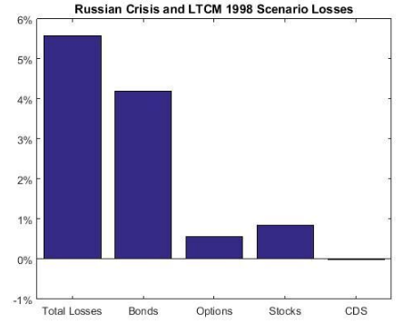

Second Scenario:

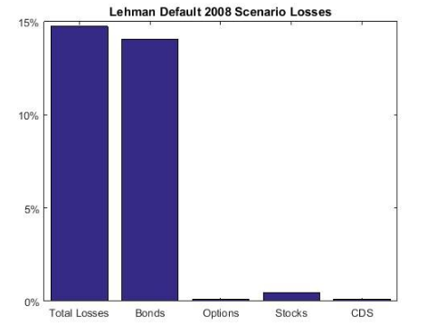

Third scenario:

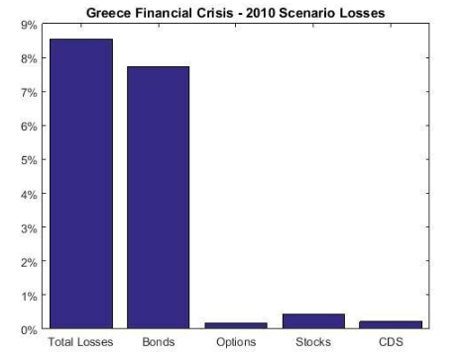

Fourth scenario:

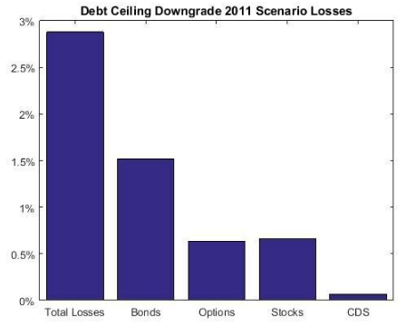

Fifth scenario:

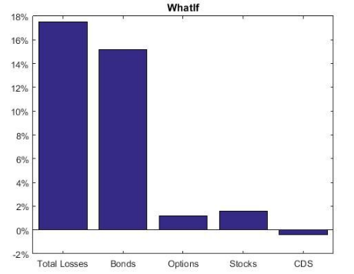

Basel Regulatory Capital

On Basel Regulatory Capital there are two principal components required to obtain the capital requirements: one market component and one risk component.

Market Regulatory Capital

Based on the Basel 2.5 document, the following formula needs to be used to calculate our market risk regulatory capital:

$$K=\max\left(VaR_{10d 99\%};mc VaR_{avr 10d 99\%}\right)+max⁡(SVaR_{10d 99\%};mc SVaR_{avr 10d 99\%})$$

Where:

K : is the regulatory capital

VaR: Value at Risk with 10-day horizon and 99% certainty

mc : regulatory constant, that the minimum number is a 3, and the maximum is 4 (depending to the regulatory authority). We are assuming a 3.1 (as a AA company with no major changes to be done in the structure of our company).

SVaR: Stressed Value at Risk for a time horizon predetermined, over 2 years. In our case, we are considering the time frame between March 2007 and December 2009, where the VaR calculation is higher. In our case it is from March 2007 to March 2009.

VaRavr : Consider the average of the last 60 days of the VaR calculation.

SVaRavr : Consider the average of the last 60 days of the Stressed VaR calculation.

To make this calculation, we decided to calculate it in a conservative way, so we are taking the historic VaR method (that is higher than the Monte Carlo simulation).

In addition, we are not considering the 60 average, although it is a requirement.

The capital regulatory is the following:

$$K=73.7 MUSD$$

Credit Regulatory Capital

Based on the Basel 2.5 document, we need to compute the Incremental Risk Charge (IRC). It is a complement for the VaR framework that includes the effect of the credit rating migration; downgrades are also considered in credit risk modeling. We are considering the same transition matrix for corporate bonds and CDS. We are considering S&P 2015 matrix for one year.

CreditMetrics methodology as well as Gaussian copulas is used to model the rating transitions. The one-year 99.9% VaR is calculated using 10000 MC simulations:

$$IRC K=⁡VaR_{1Y 99.9\%}$$

$$VaR_{1Y 99.9\%}=5.06 MUSD$$

In this example, we are not considering the CDS’s for time issues. But, if considered, the capital requirement needs to increase considerably, to around 10MUSD.

Rest of capital requirements

The following formulas are needed to compute the economic capital. For time constraints we were not able to finish them.

Economic Capital:

The Economic Capital is the Capital designated to cover unexpected Market losses. The Economic Capital provides a forward looking estimate of the difference in the maximum potential loss and our expected loss:

$$K_{economic}=VaR_{10d99\%}-Expected Loss$$

Counterparty Credit Risk (CCR):

CCR is the risk associated with the counterparty defaulting. The default risk component is calculated using the Standard or IRB approach according Basel framework. Credit Value Adjustment (CVA) capital is to mitigate the MTM losses on the expected CCR for derivatives.

Standardized Approach:

The capital allocation is based on the following formula proposed in Basel 1, where the weights and credit equivalent add-on factors are:

$$K=0.08 (Σ_{j}RWA_{j})$$

Where the ratings on the credits pay an important part on the weights to affect the debt:

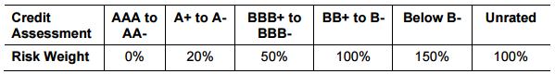

And the RWA categories are according to the following[8]:

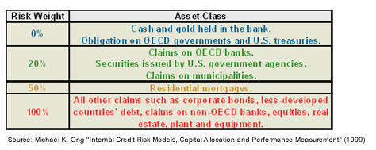

Internal Rating Based Approach (IRB):

The IRB approach is more advanced than the standardized approach and is based on the Vasicek model of the portfolio. In IRB the VaR is based on the one year 99.9% confidence interval. The default probabilities are calculated based on the CDS spread of the counterparties. The formulas and explanations of the rest of the parameters can be found in our documentation.

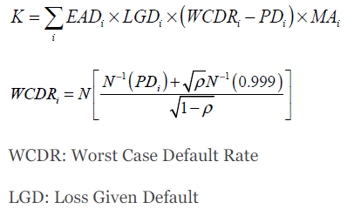

Standardized CVA Capital:

In the standardized approach, the portfolio CVA capital charge is calculated using the following formula:

1. GS, GILD, IBM
2. MET, LMT, MRK
3. USDCAD and EURCAD
4. The 15 term structure points are the following: 3M, 6M, 1Y, 2Y, 3Y, 4Y, 5Y, 6Y, 7Y, 8Y, 9Y, 10Y, 15Y, 20Y, 30Y
5. The 15 term structure points are the following: 3M, 6M, 1Y, 2Y, 3Y, 4Y, 5Y, 6Y, 7Y, 8Y, 9Y, 10Y, 15Y, 20Y, 30Y
6. The 15 term structure points are the following: 3M, 6M, 1Y, 2Y, 3Y, 4Y, 5Y, 6Y, 7Y, 8Y, 9Y, 10Y, 15Y, 20Y, 30Y
7. The 8 term structure points are the following: 6M, 1Y, 2Y, 3Y, 4Y, 5Y, 7Y, 10Y
8. http://www.investopedia.com/articles/07/baselcapitalaccord.asp